# Run Benchmark with Active Strategies (Corrected)

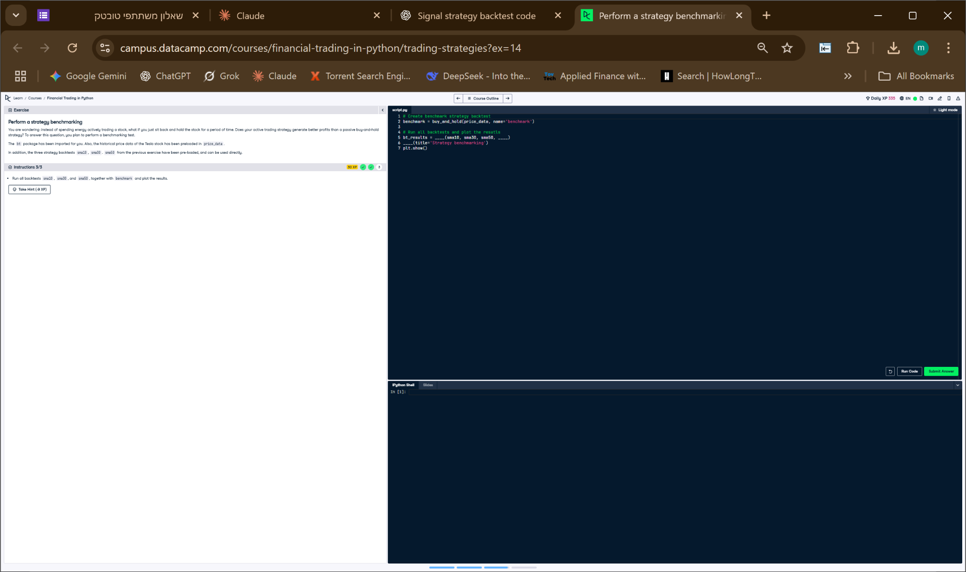

## Python Code

# Create benchmark strategy backtest  
benchmark = buy_and_hold(price_data, name='benchmark')  
  
# Run all backtests and plot the results  
bt_results = bt.run(sma10, sma30, sma50, benchmark)  
bt_results.plot(title='Strategy benchmarking')  
plt.show()

## Explanation

This code first creates a benchmark backtest using the buy-and-hold strategy. It then runs all trading strategies (SMA10, SMA30, SMA50) along with the benchmark using `bt.run()`. Finally, it plots their performance in a single chart to compare active vs. passive strategy outcomes.